3.1 EXERCISE 1: PROCESS CONTROL - FORK()

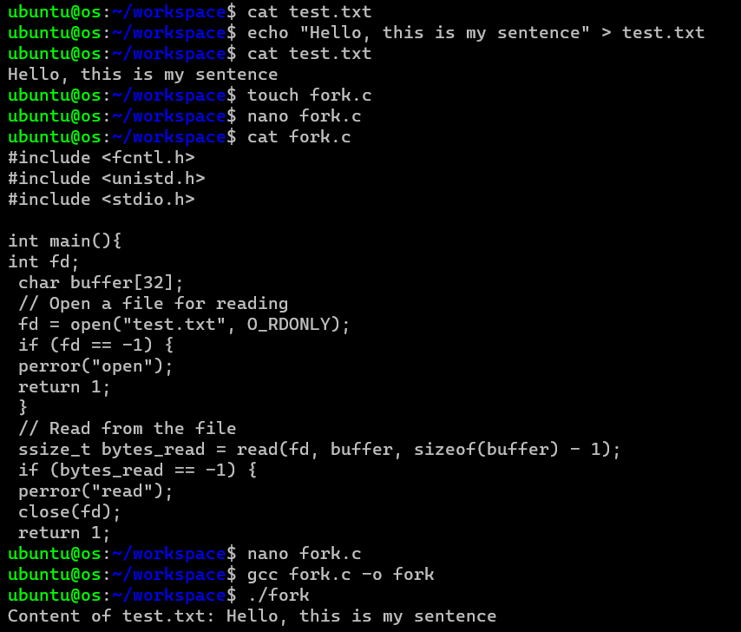

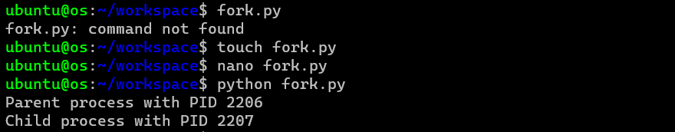

3.2 EXERCISE 2: FILE MANIPULATION - OPEN(), READ(), AND WRITE()

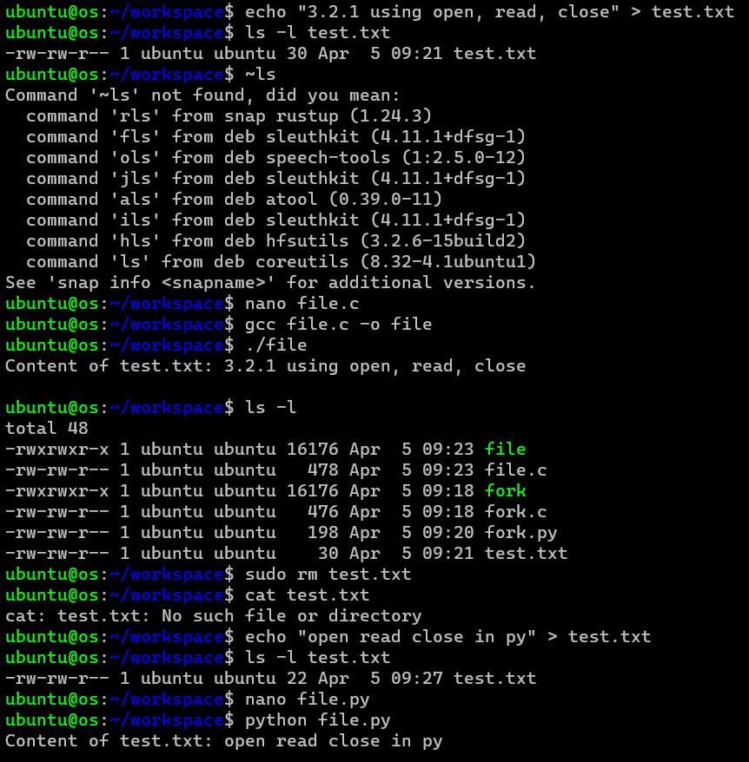

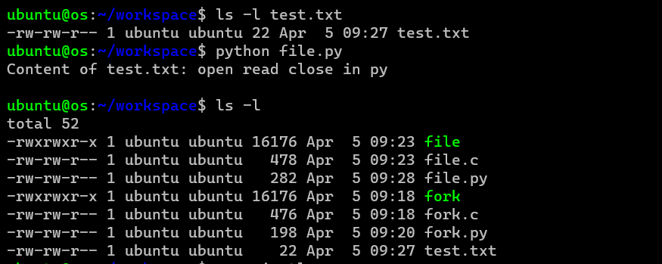

3.3 EXERCISE 3: DEVICE MANIPULATION - IOCTL()

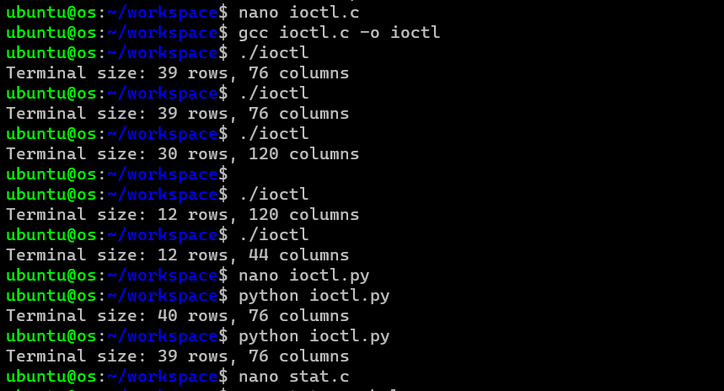

3.4 EXERCISE 4: INFORMATION MAINTENANCE - STAT()



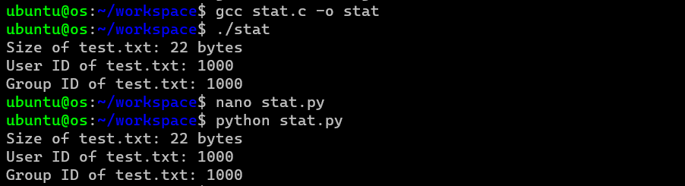

3.5 EXERCISE 5: COMMUNICATION - PIPE()

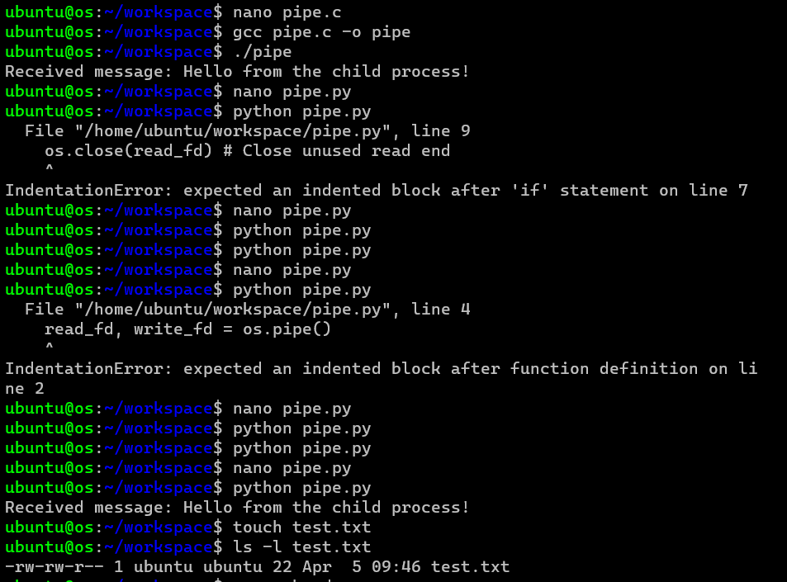

3.6 EXERCISE 6: PROTECTION - CHMOD()

